2020 Program Information

Thanks for your interest in planting trees in your neighborhood! Please fill out the information below to the best of your ability to request a tree(s) through the Grit City Trees program. The goal of this program is to assist neighborhoods of low opportunity to increase tree cover in neighborhood rights-of-way (the space between the edge of your property and the street) by providing free street trees. Through this program, we want to ensure the right tree in the right place. For tree planting see our proper tree placement webpage. Additionally, we will provide supporting materials to help your trees to thrive including tree stakes, ties, TAGRO, and watering bags for the dry months.

2020 Program Update in Response to COVID Related Budget Constraints:
The trees being offered for the program this year are coming from the City of Tacoma’s current tree stock. These trees are typically dedicated to roadway improvements or other City projects, and are a variety of sizes and species.

Contact the City of Tacoma Urban Forestry at trees@cityoftacoma.org or (253) 502-2138 for submittal or assistance. Please contact us at least a week or two prior to the application deadline, to provide enough time to address any issues.

If you would like to do a neighborhood application and would benefit from support, please contact Tacoma Tree Foundation at info@tacomatrees.org

Timeline
Aug - Sept 2019: Completed individual applications are due August 16. Completed group applications are due September 6. All applications are reviewed on a first-come first-serve basis.
September 2019: The City of Tacoma reviews applications. Confirmations are sent to residents with tree distribution details. Due to limited resources for the 2020 program year, trees will be distributed on a first-come first-serve basis. If we are unable to provide you with a tree this year, be sure to reapply for the 2021 Grit City Trees Program.
November 2019: Trees will be available at the City of Tacoma tree nursery for pick-up by individual applicants to be planted in their right-of-way. Tree delivery to neighborhood groups is available courtesy of Washington Conservation Corps. *If you need planting assistance, the Pierce Conservation District can, on a case-by-case basis, offer delivery and planting help to participants who need physical assistance or lack access to a vehicle.*

Check here if you require planting assistance:

Options for Receiving FREE Trees for your Right-of-Way (street trees)

Neighborhood Group Applications (Neighbors Planting Together):
Neighbors who organize a tree planting that involves a minimum of 10 trees and three participating residents within a two-block distance will qualify to submit a Neighborhood Group Application.
- Each individual property owner needs to submit a signed “Tree Care Agreement, Including Liability Release” form included in this packet and call for a utility locate (dial 811) to ensure there is enough planting space for new trees.
  - Please submit neighborhood applications together as a packet.
  - Successful Neighborhood Group Applications will have trees delivered by City of Tacoma to one designated drop-off address.
- If you would like assistance in facilitating conversations with your neighbors to apply for group applications, please contact Tacoma Tree Foundation at info@tacomatrees.org
- Neighborhood applications are preferred and will also receive free delivery of all trees.
Individual Request Applications:

- For individuals interested in free trees for their right-of-way, an individual property owner must submit an application along with the “Tree Care Agreement, Including Liability Release” form included in this packet and call for a utility locate (dial 811) to ensure there is enough planting space for new trees.
- Please note, there is a limited availability of trees and preference is given to group applications and those in priority locations (refer to Planting Priority Areas map).
- Successful individual applications will be required to pick up trees from the City of Tacoma Plant Holding Facility at the Recycling and Transfer Center. Confirmation regarding dates for pick-up will be sent out at least two weeks before pick-up days.

Planting Day Necessities & Suggestions:
- Call 811 or 1-800-424-5555 (www.callbeforeyoudig.org) to locate underground utilities. It is required by the Underground Utilities Damage Prevention Act to call for utility locations to be marked at each planting location before you dig.
  - For Neighborhood Group Applications, confirm that neighbors can pick-up their trees from the designated house and that everyone called 8-1-1 to have underground utilities marked.

- Tools to plant a tree:
  - Shovels
  - Gloves
  - Tarp to hold soil and turf during planting
- Water source, hose, buckets
    - Consider contacting Tacoma Tool Library if you need equipment to plant your tree.

- Review Proper Planting Practices at the City of Tacoma Urban Forestry Website.
  - Proper planting is crucial to the survival of your new tree

- Soil in the planting strip is frequently rocky and compacted. Changing existing soil can mean the difference between survival or not for your new tree(s). A great option to amend the soil is TAGRO. We can provide one bag of TAGRO per tree but loose TAGRO is available at the main TAGRO pickup location is at the Central Treatment Plant off Portland Avenue. For more information about TAGRO, please visit www.cityoftacoma.org/tagro or call (253) 502-2150.

- The City of Tacoma Urban Forestry Program will coordinate delivery of trees for Neighborhood Groups, but are unable to plant the trees. Residents and neighbors are expected to try to work together to plant and care for their Grit City Trees. If you need assistance planting, the trees check here:

Other Important Considerations:
Trees provided through the Grit City Trees Program must be planted in the right-of-way only. The space between the edge of the road and the edge of your property line. To see the extent of your right-of-way, check out Tacoma’s DART map. Search for your address in the top left corner of the screen. I find it helpful to turn on a satellite image by clicking the four squares in the top right to select a new basemap. This lets you reference features on a property and shows where your property boundary and right-of-way are.

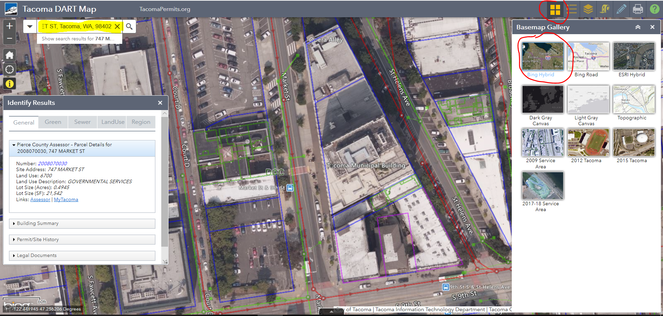

In accordance with Tacoma Municipal Code Chapter 9.17, 9.18, and 9.19, abutting property owners are allowed to landscape the planting strip and are responsible for the maintenance of the planting strip, unless otherwise specified by the City. Additionally, the full width of the sidewalk must be clear of vegetation to a height of 8 feet, so pedestrians can walk safely. The full width of the street must be clear of vegetation to a height of 14 feet, so emergency vehicles and delivery trucks have safe access.
Application for Grit City Trees

Contact Name: Email:
Daytime Phone: Alternate Phone:
Alternate Contact: Email:
Daytime Phone: Alternate Phone:
Planting Address: __________________________________________________
Number of trees requested for this address: ____________
Are there power lines or other overhead wires above the planting site? (Y/N) __________
What is the width of the planting area (planting strip): ____________
Utility locate number/ticket number: ______________________
Are you renting? (Y/N) _____ . If yes, thank you for considering Grit City Trees! Please ensure property owner is aware of the Tree Care Agreement on the last page.
*Please note: the owner of the property is required to sign the Tree Care Agreement.
To help us build a more robust program for future years, please tell us how you heard about Grit City Trees:
_________________________________________________________________________________________________
Required For Neighborhood Group Applications:

Address for delivery of trees and TAGRO: _________________________________

_________________________________

Additional information about delivery location (e.g. Drop off everything in the driveway):

________________________________________________________________________________________
Contact Person for Delivery:_____________________________________

Contact Phone Number for Delivery:_______________________________

Is designated drop-off house willing to be a pick-up site for neighbors not included in the group application? (The City of Tacoma will contact you ahead of time with more information): _________

Request your tree:
Because of the limited trees available, please write your tree species preference and acceptable alternatives. We will do our best to find a tree similar to your preference, but cannot guarantee we will be able match you with your exact request.
For the full list of species available, please see the 2020 Grit City Trees Availability List at cityoftacoma.org/gritcitytrees.

Shade Trees (25’ and taller at maturity)
Suggested Spacing: 30’ from the center of the trunk.
= please mark if you are interested in evergreen or would accept evergreen trees
Please indicate your preferences from the 2020 Grit City Trees list (hyperlink to table to be posted online) below. We will try to provide your preference, but cannot guarantee it. You are not required to accept a non-preferred tree.
Quantity Requested  Ex: 3) | Species Name  Please include at least two alternatives – quantities of each species are extremely limited.

Small Trees* (for under power lines, 15’-25’ at maturity)
Suggested Spacing: 20’ from the center of the trunk.
= please mark if you are interested in or would accept evergreen trees
*These trees are available for sites with overhead utilities or 3’-5’ foot wide planting strips. Please indicate your preferences from the 2020 Grit City Trees list (hyperlink to table to be posted online) below. We will try to provide your preference, but cannot guarantee it. You are not required to accept a non-preferred tree.
Quantity Requested  (Ex: 3) | Species Name  Please include at least two alternatives – quantities of each species are limited.

Checklist Before You Submit Your Application

_____ Tree Care Agreement and Liability Release signed and submitted by all property owners.

_____ Neighborhood Group Applications:
_____Have at least three applications from property owners been included?
_____Are there at least 10 trees total included between the applications?
_____Have you identified a single drop-off address for the trees?

_____ I have read about tree placement in the right-of-way at the “Planting in the Right-of-Way” webpage. Check the extent of your right of way at Tacoma’s DART map

_____ I have marked the locations for my new tree(s) on the attached map (pg. 8)

_____ I have requested utility locates for all properties by calling 811 (required). Note: Underground utilities may conflict with where you want to plant your trees. Please provide the 811 ticket number. ___________________

Additional information or comments:

Send completed applications via email to trees@cityoftacoma.org or send via mail to 326 East D St., Tacoma, WA 98421 (Attn: Urban Forestry). If you are unable to submit digitally or by mail, please call (253) 502-2138 to arrange alternate options to submit your application.

Tree Planting Map
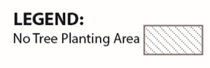
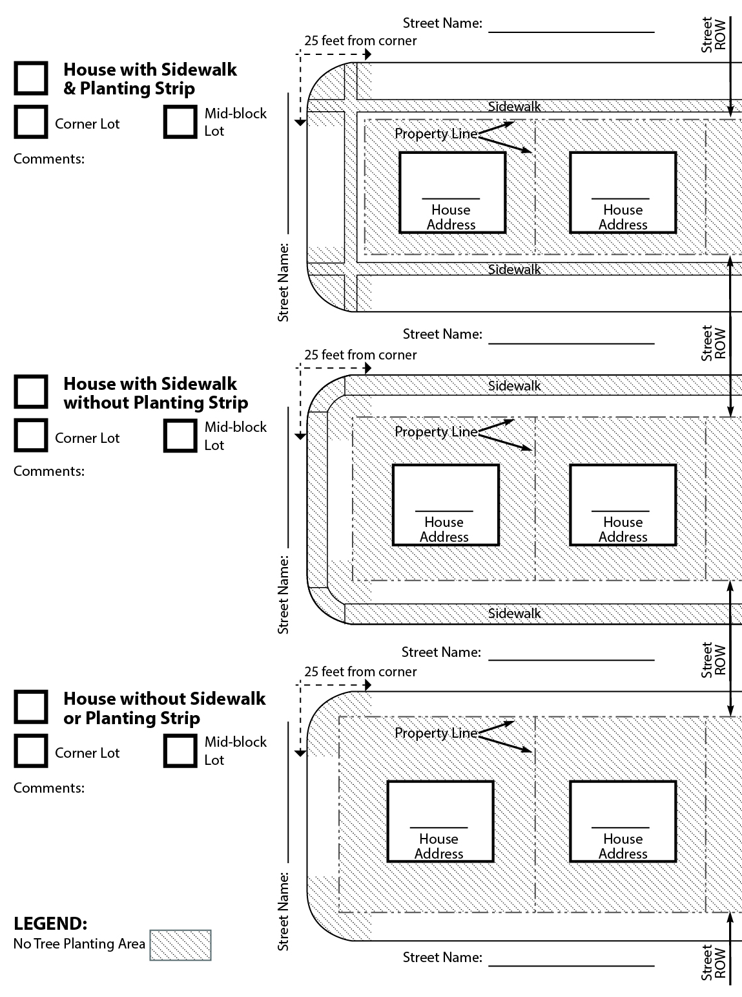
Indicate on the map which location best fits your house, and mark the locations where you intend to plant the tree(s).

TREE CARE AGREEMENT, INCLUDING LIABILITY RELEASE
City of Tacoma Street Tree Program

The undersigned ("Property Owner") wishes to participate in the City of Tacoma’s (City) Street Tree Program. In consideration for receiving a free street tree and consultation services from the City’s Urban Forester, Property Owner hereby agrees:

- To forever release, discharge and hold City, together with its officers, directors, agents, employees, representatives, and affiliates, and each and all of their respective successors and assigns (collectively, the "Released Parties ") free and harmless from any and all debts, claims, demands, damages, actions, causes of action, liabilities, losses, judgments, costs and expenses for any reason arising out of or in any way connected to Property Owner's receipt and planting of a street tree at (address) including but not limited to injury or damage incurred by Property Owner or a third party, or to Property Owner's property, in connection with any tree(s) received and planted;

- To covenant not to sue or otherwise bring any legal action against each and all of the Released Parties for or on account of any claim associated with the street tree;

- To indemnify, hold harmless and defend each and all of the Released Parties from and against any and all claims arising out of the receipt of the street tree(s) or the planting of the street tree(s), excepting those claims caused by the sole active negligence or willful misconduct of the Released Parties;

- To maintain the street tree(s), including roots, trunks, branches and leaves, so that no part of the tree(s) causes or contributes to sidewalk defects or other hazardous conditions in the right of way.

- To not top, stub cut, or otherwise prune the tree trunk and/or branches in such a manner as to permanently damage the structure of the tree, unless doing so is to specifically address potential hazardous conditions.

I HAVE READ THE FOREGOING RELEASE AND INDEMNITY IN FULL AND
VOLUNTARILY CONSENT TO ITS PROVISIONS.

Signed on: ______________________(Date) ________________________________(Location)

Property Owner’s signature:

Property Owner’s printed name:
Property Owner’s Mailing Address (if different from street tree planting location): _____________________________________________________________________________________

Address of street tree planting location:
_______________________________________________

