The content and images below can be used in parent/teacher print or online newsletters. The time frames are suggestions to modify based on your communication needs with parents/guardians. Save the images from this document by right clicking on the image and selecting “Save as Picture.”
Time | Content | image
Beginning of the school year | As a part of Physical Education this year, your child will participate in the Pedestrian Safety Education unit. Elementary school is the perfect time to establish and hone children’s safe walking habits.  This curriculum is designed to equip children with the skills and awareness to walk and cross streets safely in our community. Learning safe walking practices supports their growth as healthy, active, and aware community members. | 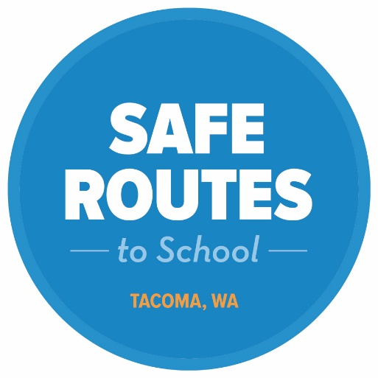
One or two weeks prior | The Pedestrian Safety Education unit begins in PE class soon! We will be learning and practicing safe walking and crossing skills by incorporating concepts into fun activities.  More information to come in [backpack mail/letter home or attach the letter to parent/guardians]. | 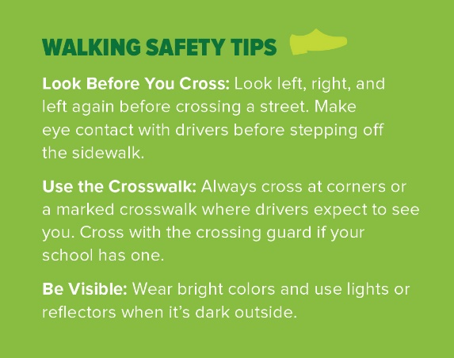
During | Your child is practicing how to safely cross streets. Practice the Pedestrian Safety Rhyme with your child each time you cross a street, alley entrance, or even a driveway!  Stop every time at the edge of the street.  Use your head before your feet.  Make sure you hear every sound,  Look left, look right, look all around! | 