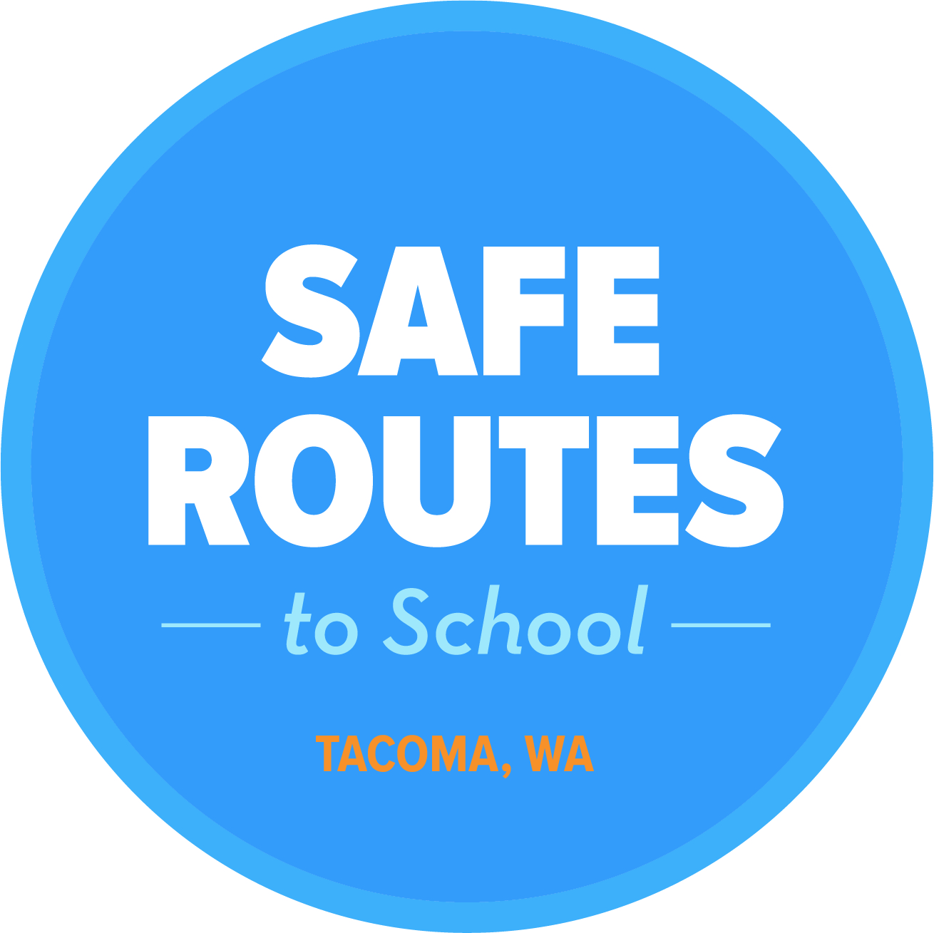Walk and Roll to School Day
Robocall and Newsletter Text

RoboCall Announcement:
October is National Walk and Roll to School month! [Insert school name] is celebrating by walking and rolling to school on [insert date]. Join other students and their families by walking, bicycling, skating, or scootering to school on [day of week, month, date]. It’s a great way to start the day, plus it helps reduce traffic around the school.

Newsletter Text:
October is National Walk and Roll to School month! [Insert school name] is celebrating by walking and rolling to school on [insert date]. Join other students and their families by walking, bicycling or skating to school too!
Walking or rolling to school is a great way to connect with the community, build healthy habits, and get more physical activity every day. Students who walk and roll to school show up ready to learn. One study showed that after walking 20 minutes, students completed learning tasks more quickly and accurately and performed better on tests of reading comprehension.
Consider walking, bicycling, or skating with your student and other members of the [insert school name] community on [insert day of week, month, date]!

Note: If your event is going to include additional items, such as snacks or a raffle, mention it in the robocall and newsletter text.

