BMP C131: Gradient Terraces

Purpose
Gradient terraces reduce erosion damage by intercepting surface runoff and conveying it to a stable outlet at a non-erosive velocity.

Conditions of Use
Gradient terraces normally are limited to denuded land having a water erosion problem. They should not be constructed on deep sands or on soils that are too stony, steep, or shallow to permit practical and economical installation and maintenance. Gradient terraces may be used only where suitable outlets are or will be made available. See Figure 3 - 6: Gradient Terraces for gradient terraces.

Design and Installation Specifications
The maximum vertical spacing of gradient terraces should be determined by the following method:
(Equation 3 - 1)

VI =
(0.8)s + y

Where:
VI = vertical interval in feet
s = land rise per 100 feet, expressed in feet
y = a soil and cover variable with values from 1.0 to 4.0

Values of “y” are influenced by soil erodibility and cover practices. The lower values are applicable to erosive soils where little to no residue is left on the surface. The higher value is applicable only to erosion-resistant soils where a large amount of residue (1½ tons of straw/acre equivalent) is on the surface.
- The minimum constructed cross-section should meet the design dimensions.
- The top of the constructed ridge should not be lower at any point than the design elevation plus the specified overfill for settlement. The opening at the outlet end of the terrace should have a cross section equal to that specified for the terrace channel.
- Channel grades may be either uniform or variable with a maximum grade of 0.6 feet per 100 feet length. For short distances, terrace grades may be increased to improve alignment. The channel velocity should not exceed that which is non-erosive for the soil type with the planned treatment.
- All gradient terraces should have adequate outlets. Such an outlet may be a grassed waterway, vegetated area, or tile outlet. In all cases, the outlet must convey runoff from the terrace or terrace system to a point where the outflow will not cause damage. Vegetative cover should be used in the outlet channel.
- The design elevation of the water surface of the terrace should not be lower than the design elevation of the water surface in the outlet at their junction, when both are operating at design flow.

- Vertical spacing determined by the above methods may be increased as much as 0.5 feet or 10 percent, whichever is greater, to provide better alignment or location, avoid obstacles, adjust for equipment size, or reach a satisfactory outlet.
- The contributing area above the top should not exceed the area that would be drained by a terrace with normal spacing.
- The terrace should have enough capacity to handle the peak volumetric flowrate expected from a Type 1A, 2-year, 24-hour frequency storm without overtopping.
- The terrace cross-section should be proportioned to fit the land slope. The ridge height should include a reasonable settlement factor. The ridge should have a minimum top width of 3 feet at the design height. The minimum cross-sectional area of the terrace channel should be 8 square feet for land slopes of 5 percent or less, 7 square feet for slopes from 5 to 8 percent, and 6 square feet for slopes steeper than 8 percent. The terrace can be constructed wide enough to be maintained using a small cat.

Maintenance Standards
Maintenance should be performed as needed. Terraces should be inspected regularly, at least once a year, and after large storm events.

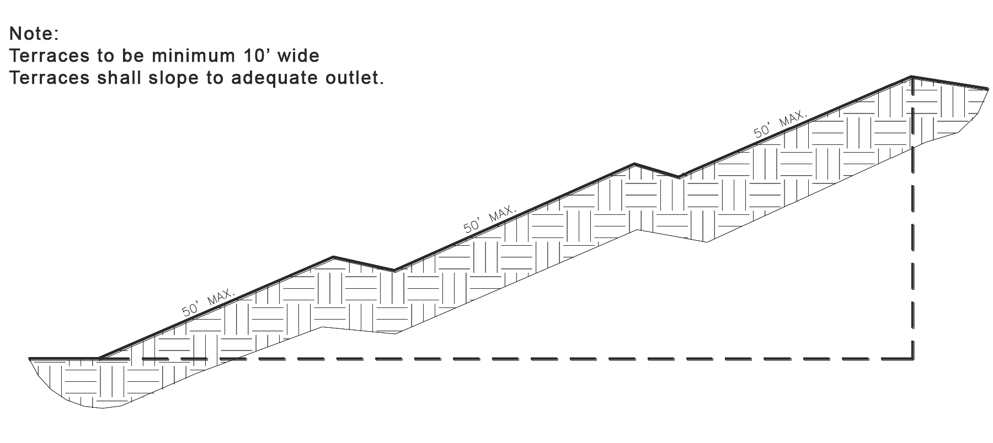
Figure 3 - 6: Gradient Terraces

