  - BMP C202: Rip Rap Channel Lining

Purpose
To protect erodible channels by providing a channel liner using either blankets or riprap.

Conditions of Use
      - Use this BMP when natural soils or vegetated stabilized soils in a channel are not adequate to prevent channel erosion.
      - Use this BMP when a permanent ditch or pipe system is to be installed and a temporary measure is needed.
      - The Federal Highway Administration recommends not using flexible liners whenever the slope exceeds 10 percent or the shear stress exceeds 8 pounds per square foot.

Design and Installation Specifications
      - See BMP C122: Nets and Blankets for information on blankets.
      - Since riprap is used where erosion potential is high, construction must be sequenced so the riprap is put in place with the minimum possible delay (see Figure 3 - 11: Soil Erosion Protection – Rip Rap Protection).
      - Only disturb areas where riprap is to be placed if final preparation and placement of the riprap can immediately follow the initial disturbance. Where riprap is used for outlet protection, place the riprap before or in conjunction with the construction of the pipe or channel so it is in place when the pipe or channel begins to operate.
      - The designer, after determining the appropriate riprap size for stabilization, shall consider that size to be a minimum size and then, based on riprap gradations actually available in the area, select the size or sizes that equal or exceed the minimum size. Consider the possibility of damage when selecting a riprap size, especially if there is nearby water or a gully in which to toss the stones. See Volume 5, Section 4.3: Open Channel Specifications for additional channel protection guidance.
      - Use field stone or quarry stone of approximately rectangular shape for the riprap. The stone shall be hard and angular and of such quality that it will not disintegrate on exposure to water or weathering and shall be suitable in all respects for the purpose intended.
      - Place a lining of engineering filter fabric (geotextile) between the riprap and the underlying soil surface to prevent soil movement into or through the riprap. The geotextile should be keyed in at the top of the bank.
      - Do not use filter fabric on slopes steeper than 1-1/2H:1V as slippage may occur. It should be used in conjunction with a layer of coarse aggregate (granular filter blanket) when the riprap to be placed is 12 inches and larger.

Maintenance Standards
      - Replace riprap as needed.

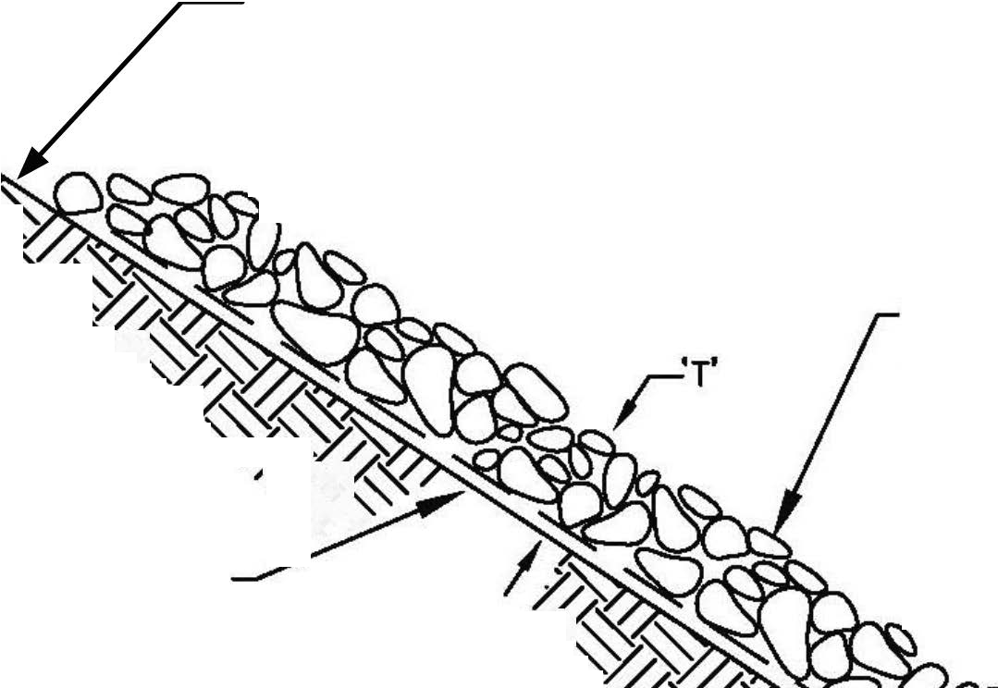Figure 3 - 11: Soil Erosion Protection – Rip Rap Protection
KE5 I% FIL.E) FAB)IC
A. .&( &F,L&(E
'* F!1E* t ,
2
·¼
C"-- 1 '* C#- 2 DE-IG%ED -.'%E -I8E

T'
-$''.H F'2%DTI'%
2%DE* FI /E*

G+3E FI .E* 6" (1509:)
FIL.E* FAB*IC '* -A%D A%D
$I%I$2$ 0HICK%E,,

T'

KE7A6 A. /'E 'F -L'( E

TYPI.CAL .SE.CTIlli
NOTE:
MINIMUM TICKNESS, T, SHAL L BE 1.5" THE MA IMUM STONE DIAMETER, NEVER LESS THAN 6" (150!!).

