BMP C154: Concrete Washout Area

Purpose
Prevent or reduce the discharge of pollutants to stormwater from concrete waste by conducting washout offsite, or performing onsite washout in a designated area to prevent pollutants from entering surface waters or groundwater.

Conditions of Use
Use concrete washout best management practices on construction projects where:
      - It is not possible to dispose of all concrete wastewater and washout offsite (ready mix plant, etc.)
      - Concrete truck drums are washed onsite.

      - Concrete is used as a construction material.

At no time shall concrete be washed off into the footprint of an area where an infiltration feature will be installed.
Note: Auxiliary concrete truck components (e.g. chutes and hoses) and small concrete handling equipment (e.g. hand tools, screeds, shovels, rakes, floats, trowels, and wheelbarrows) may be washed into formed areas awaiting concrete pour.

Design and Installation Specifications

Implementation
      - Perform washout of concrete truck drums at an approved offsite location or in designated concrete washout areas only.
      - Do not wash out concrete trucks onto the ground, or into the stormwater conveyance system, open ditches, streets, or streams.
      - Do not allow excess concrete to be dumped onsite, except in designated concrete washout areas.
      - Wash equipment difficult to move, such as concrete paving machines, in areas that do not directly discharge to natural or constructed stormwater conveyance or potential infiltration areas.
      - Concrete washout areas may be prefabricated concrete washout containers, or self- installed structures (above-grade or below-grade).
      - Prefabricated containers are most resistant to damage and protect against spills and leaks. Companies may offer delivery service and provide regular maintenance and disposal of solid and liquid waste.

      - If self-installed concrete washout areas are used, below-grade structures are preferred over above-grade structures because they are less prone to spills and leaks.

      - Self-installed above-grade structures should only be used if excavation is not practical.

      - Identify concrete washout area on the TESC plan.

      - Concrete washout areas shall be constructed and maintained in sufficient quantity and size to contain all liquid and concrete waste generated by washout operations.

Education
      - Discuss the concrete management techniques described in this BMP with the ready-mix concrete supplier before any deliveries are made.
      - Educate employees and subcontractors on the concrete waste management techniques described in this BMP.
      - Arrange for the contractor's superintendent or Erosion and Sediment Control Lead (BMP C160: Erosion and Sediment Control Lead) to oversee and enforce concrete waste management procedures.
      - Install a sign adjacent to each temporary concrete washout facility to inform concrete equipment operators to utilize the proper facilities.

Contracts
Incorporate requirements for concrete waste management into concrete supplier and subcontractor agreements.

Location and Placement Considerations:
      - Locate washout area or temporary concrete washout facilities at least 50 feet from sensitive areas such as stormwater system inlets, open conveyance ditches, or waterbodies, including wetlands.
      - Allow convenient access for concrete trucks, preferably near the area where the concrete is being poured.
      - If trucks need to leave a paved area to access washout, prevent track-out with a pad of rock or quarry spalls (BMP C105: Stabilized Construction Entrance/Exit). These areas should be far enough away from other construction traffic to reduce the likelihood of accidental damage and spills.
      - The washout area volume installed should depend on the expected demand for storage capacity.
      - On large sites with extensive concrete work, washouts may be placed in multiple locations for ease of use by concrete truck drivers.

Concrete Truck Washout Procedures
      - Washout concrete truck drums in designated concrete washout areas only.
      - Concrete washout from concrete pumper bins can be washed into concrete pumper trucks and discharged into designated concrete washout areas or properly disposed of offsite.

Concrete Washout Area Installation
      - Install concrete washout areas prior to starting concrete work.
      - Construct concrete washout areas of sufficient quantity and volume to contain all liquid and concrete waste generated by washout operations. It is recommended that the minimum length and width be 10 feet.

      - Plastic lining should be a minimum of 10-mil polyethylene sheeting and free of holes, tears, or other defects that compromise impermeability.
      - Lath and flagging should be commercial grade.
      - Install liner seams per manufacturer's recommendations.
      - Prepare soil base free of rocks or other debris that may cause tears of holes in plastic lining.

Inspection and Maintenance
      - Inspect and verify that concrete washout BMPs are in place prior to the commencement of concrete work.
      - Once concrete wastes are washed into designated washout areas and allowed to harden, the concrete should be broken up, removed, and disposed of per applicable solid waste regulations. Dispose of hardened concrete on a regular basis.
      - During periods of concrete work, inspect daily to verify continued performance.
        - Check overall condition and performance.
        - Check remaining capacity (% full).
        - If using self-installed washout facilities, verify plastic liners are intact and sidewalls are not damaged.
        - If using prefabricated containers, check for leaks.
      - Maintain washout facilities to provide adequate holding capacity with a minimum freeboard of 12 inches.
      - Washout facilities must be cleaned, or new facilities must be constructed and ready for use once the washout is 75% full.
      - If the washout is nearing capacity, vacuum and dispose of the waste material in an approved manner.
        - Do not discharge liquid or slurry to streets, the stormwater system, receiving waterbodies, or the ground..
        - Do not use wastewater system without obtaining a City of Tacoma Special Approved Discharge permit. Call Source Control at 253.591.5588 for more information.
        - Place a secure, non-collapsing, non-water collecting cover over the concrete washout facility prior to predicted wet weather to prevent accumulation and overflow of precipitation.
        - Remove and dispose of hardened concrete and return the structure to a functional condition. Concrete may be reused onsite or hauled away for disposal or recycling.
      - When you remove materials from the self-installed concrete washout, build a new structure; or, if the previous structure is still intact, inspect for signs of weakening or damage, and make any necessary repairs. Re-line the structure with new plastic after each cleaning.

Removal of Temporary Concrete Washout Facilities
      - When temporary concrete washout facilities are no longer required for the work, remove and properly dispose of the hardened concrete, slurries and liquids.

      - Remove materials used to construct temporary concrete washout facilities from the site of the work and dispose of or recycle it.
      - Holes, depressions or other ground disturbance caused by the removal of the temporary concrete washout facilities shall be backfilled, repaired, and stabilized to prevent erosion.

.
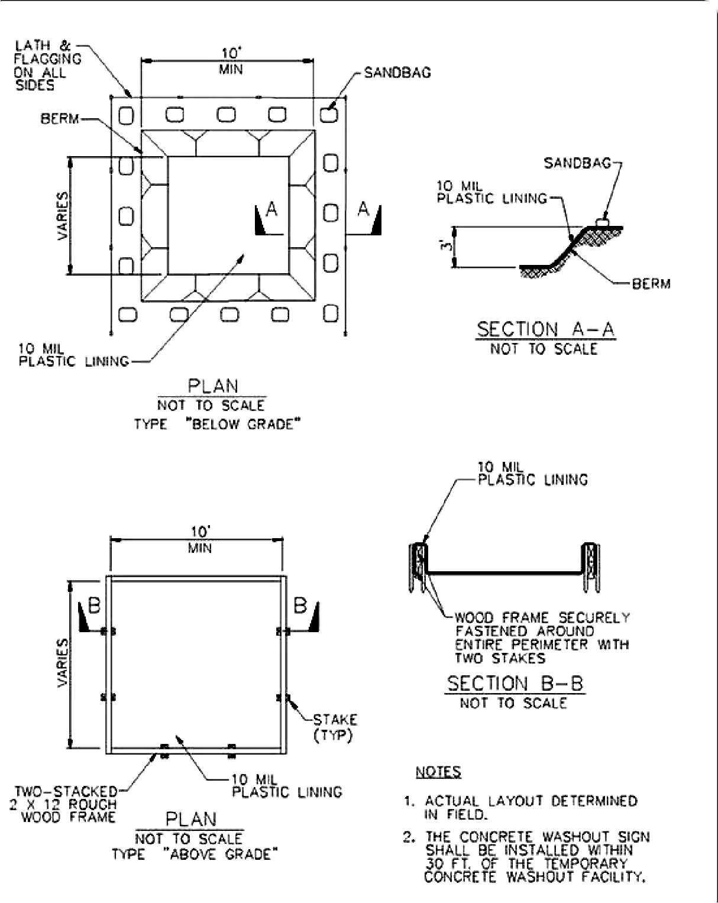

Figure 3 - 7: Temporary Concrete Washout Facility

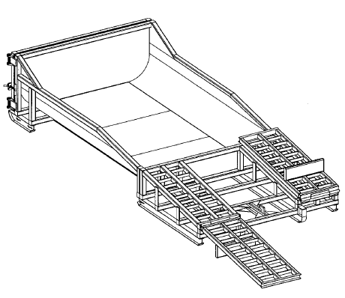
Figure 3 - 8: Prefabricated Concrete Washout Container with Ramp

